 | State of South Carolina  Request for Information  (RFI) | Solicitation: Date Issued: Procurement Officer:  Phone: E-Mail Address: Mailing Address: | 5400029909  6/16/26  Elsie Montgomery  (803) 737-1178  Elsie.montgomery@admin.sc.gov  Dept of Administration  1200 Senate St  Columbia, SC 29201

DESCRIPTION: AAR Reimagining – Evaluation, Redesign, and Development of a Statewide Performance Management System

Submit your response via email to Elsie.Montgomery@admin.sc.gov with [Your Company Name] - AAR Reimagining RFI# 5400029909 in the subject line.

SUBMIT RFI RESPONSE BY: July 23, 2026, at 5:00 PM EST

Table of Contents

1. Overview……………………………………………………………………………………………………………….. 3
2. General Information…………………………………………………………………………………………………... 3
3. Request for Information (RFI)…………………………………………………………………………………….......3
4. Disclaimers……………………………………………………………………………………………………………... 4
5. Confidentiality…………………………………………………………………………………………………………. 5
6. Response Instructions…………………………………………………………………………………………………..6
7. Questions for Response……………………………………………………………………………………………....... 7
8. Attachment 1 - Scope of Work……..……………………………………………………………………………….....10

9. Attachment 2 - Current State Annual Accountability Report (AAR) Workflow….……………………………....14

RFI# 5400029909

OVERVIEW

The South Carolina Department of Administration (Admin), Executive Budget Office (EBO) is seeking information from qualified vendors for the AAR Reimagining Project — an initiative to evaluate, redesign, and modernize the Agency Accountability Report (AAR) process and develop an integrated Performance Management System (PMS) to streamline statewide reporting and performance measurement.
The AAR is required annually by all state agencies, due September 15, and serves as a critical mechanism for reporting performance, accountability, and outcomes to the Governor, General Assembly, and the public. The PMS will support 98 state agencies and provide a more efficient, consistent, and data-driven process. The new system should allow for:
- Streamlined data collection and reporting;
- Standardized templates and metrics;
- Objective performance measurement, and;
- Improved accessibility and transparency for the Governor, General Assembly, and the public.
The AAR Reimagining Project will establish a system and framework that reduces administrative burden, enhances reporting quality, and enables performance comparison across agencies. The intent of this RFI is to gather information for a proposed PMS regarding available services, pricing structures, and industry best practices that will help refine the forthcoming solicitation. This RFI does not constitute a solicitation or request for proposal, and participation does not provide preference in any future procurement.

GENERAL INFORMATION
This RFI is being issued with the goal of gathering information for market research and planning purposes only. Respondents are responsible for all expenses associated with responding to this RFI.
Ownership of all material and documentation originated, prepared, and provided to Admin during this RFI process will belong to the EBO.

REQUEST FOR INFORMATION (RFI)
The intent of this RFI is to provide interested contractors with information about current needs, while seeking information for exploratory purposes. The information gathered will be used to determine the availability of vendors capable of providing desired products and services. This RFI is an information gathering and market research tool, not a formal solicitation of a specific requirement (such as in a “Request for Proposals” document) and; therefore, no contract will be awarded by Admin from this RFI.

DISCLAIMERS
This is an RFI issued solely for information and planning purposes. Admin does not intend to award a contract as a result of this RFI, nor does Admin guarantee that a public solicitation will be issued as a result of this RFI.
The Admin Procurement Office will acknowledge receipt of the information provided by respondents, but is not under obligation to provide evaluative feedback to them.
This RFI shall not limit any rights to respond if duly qualified. Without limiting the generality of the foregoing, the EBO expressly reserves the right, at their discretion:
- to seek subsequent information or initiate discussions with any firm, including firms who did not respond to this RFI;
- to initiate direct negotiations for the procurement of any goods or services with any firm or firms regardless of whether the firm or firms responded to this RFI;
- to contact a limited number of firms, which may be limited to those who responded to this RFI or may include firms who did not respond to this RFI, for the purpose of competitive procurement of any good or service;
- to elect to proceed by way of an open tender call where all potential firms, including those who did not respond to this RFI, are eligible to compete for the award of a contract for the supply of any good or service; or
- to elect not to procure the good or service subject to this RFI.

These expressly reserved rights are in addition to any and all other rights of the State.
Any pricing information provided by Respondents is for general information purposes and is not intended to be binding on Respondents. Any legally binding pricing or purchasing commitments will only be established where specified by the express terms of a subsequent tender call process or were established through the execution of a written agreement. The EBO and their advisors make no representation, warranty, or guarantee regarding the accuracy of the information contained in the RFI or issued by addenda. Any quantities shown or data contained in this RFI, or provided by way of addenda, are estimates only provided as general background information.
Neither Admin nor EBO shall be liable for any expenses, including the expenses associated with preparing responses to this RFI. The parties shall bear their own costs associated with or incurred through this RFI process, including any costs arising out of or incurred in: (a) the preparation and issuance of this RFI; (b) the preparation and making of a submission; or (c) any other activities related to this RFI process.
The Respondent acknowledges that the information provided is complete and accurate to the best of its knowledge. The Respondent must ensure that the submitted material is approved for distribution to the EBO and any affiliates. Respondents should identify any information in their submission, or any accompanying documentation supplied in confidence, for which confidentiality is to be maintained by the EBO. The confidentiality of such information will be maintained by the EBO, except where an order by a law enforcement agency or a court requires the EBO to do otherwise. As mentioned under “Confidentiality”, the Respondent is responsible for specifying company-specific trade secrets in need of protection from potential FOIA requests, where public disclosure of said trade secrets would harm the company.
Except where expressly set out to the contrary in this RFI or in the Respondent’s submission, the submission and any accompanying documentation provided by a Respondent shall not be returned.

CONFIDENTIALITY
If any of the information in the Respondent’s response is considered confidential, proprietary, or a trade secret, it must be clearly indicated on the appropriate page of the response. Release of such materials is governed by the South Carolina Freedom of Information Law, which in pertinent part requires the requester to provide specific justification as to why disclosure of particular information in the response would cause substantial injury to the competitive position of the Respondent. As stated under "Disclaimers" above, it is incumbent upon the Respondent to specify company-specific trade secrets in need of protection where public disclosure of said trade secrets would harm the company.
Public Access to Procurement Information in South Carolina: -http://www.scstatehouse.gov/code/t11c035.php

SECTION 11-35-410. Public access to procurement information.
(A) Procurement information must be a public record to the extent required by Chapter 4, Title 30 (The Freedom of Information Act), except as otherwise provided by this code, and with the exception that commercial or financial information obtained in response to a request for proposals or any type of bid solicitation that is privileged and confidential need not be disclosed. (B) Privileged and confidential information is information in specific detail not customarily released to the general public, the release of which might cause harm to the competitive position of the party supplying the information. Examples of this type of information include:
- customer lists;
- design recommendations and identification of prospective problem areas under an RFP;
- design concepts, including methods and procedures;
- biographical data on key employees of the bidder.
(C) The board shall promulgate regulations directing the public availability and disposition of documents submitted in response or with regard to a solicitation or other request where no award is made.
(D) For all documents submitted in response or with regard to any solicitation or other request, the person submitting the documents shall comply with instructions provided in the solicitation for marking information exempt from public disclosure. Information not marked as required by the applicable instructions may be disclosed to the public.
(E) A governmental body, with the approval of the appropriate chief procurement officer, may keep portions of a solicitation confidential and release the information to prospective offerors only upon execution of a nondisclosure agreement, provided the information is otherwise exempted from disclosure by law.
(F) If requested in writing before a final award by an actual bidder, offeror, contractor, or subcontractor with regard to a specific intended award or award of a contract, the procurement officer shall, within five days of the receipt of any such request, make documents directly connected to the procurement activity and not otherwise exempt from disclosure available for inspection at an office of the responsible procurement officer. Without otherwise limiting any other exemptions granted by law, and except as provided herein, documents of and documents incidental to proposed contractual arrangements, including those used for contract negotiations, are not exempt from disclosure after the date notice of intent to award is posted, unless the notice is subsequently canceled.

RESPONSE INSTRUCTIONS
Vendors are requested to respond to all questions included in this RFI.

Document Format
Responses should be provided within the document directly below each question, maintaining the original formatting of this document. Please provide the information in the exact order listed below to facilitate the review of the responses. Please rename this document with the following naming convention: AAR Reimagining RFI#5400029909 VENDOR NAME.docx (.doc format is also acceptable).
Please include in your response Company Name, Point of Contact (Name/Title), Email Address, Phone Number and Company Website Address.

Questions to this RFI must be received by June 23, 2026, at 5:00 PM EST. Submit questions via email to: elsie.montgomery@admin.sc.gov.

Responses to the RFI are due by July 23, 2026, at 5:00 PM EST. Submit responses via email to: elsie.montgomery@admin.sc.gov

Late responses will not be considered.

QUESTIONS FOR VENDOR RESPONSE

NOTE: When answering the following questions, please be as detailed as possible in your response. Remember, the purpose of the RFI is to allow the vendor community to educate the State in their specific industry so that we may ultimately decide whether we will issue a solicitation for those supplies or services.

Question 1
Provide a brief background of your company.

Question 2
List your history of consultations or advisory engagements with state governments related to performance measurement system.

Question 3
Do you have any specific experience with balanced scorecard measures or outcome measures used by state governments? If so, provide examples of this type of work.

Question 4
A draft Scope of Work (SOW) is attached to this RFI (Attachment 1). Which components of this draft SOW are clear and reasonable? Which may require clarification?

Question 5
Moving away from our current manual, template-driven workflow, how should the Annual Accountability Report (AAR) structure and data breakdown process be redesigned to improve system usability for State Agencies and maximize overall operational efficiency? Specifically, what product features, data standardization models, or business intelligence and analytics capabilities are essential within your platform to support automated, cross-agency performance comparisons and multi-year trend visualization? [Vendors must review the current AAR process detailed in Attachment 2 and evaluate historical reporting formats via the South Carolina Legislature Online - Current State Agency Reports portal, to ensure full contextual alignment with the State’s existing reporting framework.]

Question 6
What modern technologies, frameworks, or software solutions would you recommend for this type of performance management system?

Question 7
What features or functionalities are essential for improving data integrity and usability?

Question 8
How can the system best support performance measurement and cross-agency comparisons?

Question 9
What are the anticipated cost drivers (e.g., licensing, customization, hosting, training)?

Question 10
How should the implementation be phased to minimize disruption to annual reporting? Propose an outline of work with a corresponding timeline.

Question 11
What best practices or case studies from other states or public sector performance systems could inform system design?

Question 12
What data security and access control measures are recommended?

Question 13
What ongoing support, hosting, and maintenance models are typically used for such systems?

Question 14
What information would you require from the EBO to provide accurate pricing or implementation estimates?

Question 15
How would you recommend structuring the system to allow continuous improvement and scalability?

Question 16
What are potential risks or challenges in implementing a system like this, and what mitigations would you suggest?

ATTACHMENT 1

SCOPE OF WORK (SOW)
The Contractor shall provide professional consulting, design, and implementation services to support the South Carolina Department of Administration (Admin), Executive Budget Office (EBO) in evaluating, redesigning, and modernizing the Agency Accountability Report (AAR) and developing a Performance Management System (PMS) to improve statewide reporting, performance measurement, and accountability. The State strongly prefers a configurable, vendor‑hosted Software‑as‑a‑Service (SaaS) solution that requires minimal customization. Vendors may propose alternative approaches; however, justification must be provided that clearly outlines why the alternative offers superior value, reduced risk, or greater alignment with State needs. The State strongly prefers vendors with proven experience working with state agencies or similar public-sector organizations, particularly in projects focused on performance measurement, data reporting, or process modernization.

1.1 Objectives
    - Evaluate the current AAR process, structure, and reporting methods to identify inefficiencies, redundancies, and improvement opportunities.
    - Redesign the AAR framework to establish a consistent, intuitive, and meaningful format for agency performance reporting.
    - Develop a PMS to automate data collection, facilitate analysis, and generate visual, report-ready outputs for internal and public use.
    - Enhance Accountability by providing clear, comparable, and measurable performance information to the Governor, General Assembly, and public.

1.2 Service Categories
The Contractor shall provide services under the following categories:

    - Business Process Evaluation and Analysis
      - Review the current AAR development and submission process.
      - Conduct stakeholder interviews and workflow mapping to document agency pain points and process inefficiencies.
      - Identify data redundancies, formatting inconsistencies, and integration challenges.
      - Provide a comprehensive Current State Assessment Report summarizing findings and recommendations for improvement.

    - AAR Redesign and Framework Development
      - Develop a modernized and standardized AAR framework aligned with the state’s performance and accountability goals.
      - Define standard data fields, performance indicators, and reporting categories applicable across agencies.
      - Create a flexible structure that accommodates unique agency missions while maintaining consistent statewide comparability.
      - Recommend visual and functional enhancements to improve user experience and report readability.

    - System Design and Development
      - Design and develop a secure, web-based Performance Management System (PMS) to manage the AAR submission and review process.
      - Include workflow automation for submission, review, approval, and publication.
      - Implement pre-population of prior-year data and change tracking to improve accuracy and efficiency.
      - Enable configurable templates for each agency without requiring manual redesign.
      - Incorporate version control, audit trails, and data validation features.

    - Performance Data Management and Analytics
      - Develop a central database for capturing and storing agency performance data.
      - Enable trend analysis and cross-agency comparison capabilities.
      - Provide built-in analytics dashboards with visualizations such as charts, graphs, and scorecards.
      - Allow role-based access for internal use and configurable views for public transparency reporting.

    - Integration and Interoperability
      - Ensure compatibility with existing state systems and data sources (e.g., budgeting, HR, finance).
      - Support import/export functionality with common formats (Excel, CSV, PDF, XML).
      - Design the system architecture for scalability and potential future integrations.

    - Training, Documentation, and Change Management
      - Develop and deliver end-user training materials for agency personnel and EBO administrators.
      - Provide system administration guides, user manuals, and technical documentation.
      - Conduct live and recorded training sessions to ensure adoption and ease of use.
      - Offer post-implementation support during the first full AAR reporting cycle.

  - Deliverables
The items listed below represent the core baseline deliverables required for this project. If EBO identifies additional specific deliverables required prior to solicitation release, they will be explicitly appended to this section to guarantee vendor provision.

At a minimum, the Contractor shall provide the following deliverables:

    - Current State Assessment Report – documenting existing workflows, challenges, and recommendations.
    - Future State Framework – outlining redesigned AAR templates, process maps, and performance indicator structure.
    - System Design Document – describing architecture, data models, integrations, and technical specifications. The system must support Single Sign‑On (SSO) and Multi‑Factor Authentication (MFA) through the State’s identity management provider, preferably Azure Active Directory. The system must include role‑based access control, audit logging, and administrative monitoring tools.
    - Configured Performance Management System – web-based, tested, and ready for pilot deployment. The proposed Performance Management System (PMS) must be hosted in a FedRAMP‑authorized or State‑approved cloud environment (e.g., Azure Government, AWS GovCloud, or equivalent). The vendor shall provide all hosting, data backup, disaster recovery, monitoring, and system maintenance services as part of the fully managed solution.
    - Pilot Implementation Report – including feedback, performance results, and enhancement recommendations.
    - Training and Support Plan – covering onboarding, system use, and technical support protocols.
    - Final Implementation Plan – roadmap for full statewide rollout and continuous improvement.
    - Additional and Future Deliverables – Vendors are advised that this list is not exhaustive. The State reserves the right to expand, modify, or add to this list of deliverables during the subsequent solicitation or contract phases. For any unknown or evolving needs that arise after solicitation release or contract execution, deliverables may be added to the scope of work at a later date, subject to formal written amendment and mutual agreement by both parties.

  - Security & Compliance

    - The Contractor shall comply with applicable state and federal cybersecurity, privacy, and accessibility standards.
    - The Contractor shall implement and maintain secure data transmission and encryption protocols for all data, both at rest and in transit.
    - The Contractor shall integrate role-based access control and comprehensive audit logging within the provided system.
    - The Contractor shall ensure full compliance with the National Institute of Standards and Technology (NIST) guidelines and South Carolina state cybersecurity frameworks.
    - The Contractor shall ensure all deliverables adhere strictly to Section 508 accessibility standards and Americans with Disabilities Act (ADA) compliance regulations.
    - The Contractor shall maintain executed confidentiality agreements for all project personnel throughout the duration of the contract.
    - The Contractor shall prohibit any data transfer, replication, or storage on non-approved systems without prior written authorization from EBO.

  - Performance and Service Levels

The Contractor shall maintain the following service level expectations during implementation and post-deployment support. Response times shall commence immediately upon the Contractor becoming aware of the issue, or when the Contractor reasonably ought to have been aware of the issue, including but not limited to the receipt of an automated system alert or a direct notification from EBO.
Priority Level | Response Time | Resolution/Mitigation
P1 – Critical (System Down) | Within 1 hour | Within 4 hours
P2 – High (Major Impact) | Within 2 hours | Within 8 hours
P3 – Medium (Functional Impact) | Within 1 business day | Within 3 business days
P4 – Low (Minor or Cosmetic) | Within 2 business days | Within 5 business days

  - Contractor Personnel Requirements

    - Personnel shall demonstrate expertise in business process analysis, performance management system development, and public-sector reporting modernization.
    - Key staff should hold certifications in relevant disciplines (e.g., Project Management Professional (PMP), Certified Business Analysis Professional (CBAP), or equivalent).
    - Technical personnel shall possess experience in system architecture, data integration, and user interface design for large-scale government applications.
    - A dedicated Project Manager and Business Analyst shall be assigned for the project duration.
    - Personnel assigned to this project shall not be replaced without the prior written approval of EBO.

  - Project Management and Governance

The Contractor shall provide comprehensive project management support, including:

    - Regular progress reporting and project dashboards.
    - Risk identification and mitigation planning.
    - Coordination with Department of Administration staff.
    - Participation in governance meetings and review sessions.
    - Use of established project management methodologies (Agile, Waterfall, or hybrid).
1.8 Ordering of Services

Services shall be authorized by the Department of Administration on an as-needed basis. Such services shall be initiated through a Work Order Request, issued by the Department of Administration. Each Work Order Request shall define the scope of work, deliverables, and period of performance or schedule.

The Contractor must respond with a Work Order that at minimum includes the Contractor’s:

- proposed methodology/services
- proposed personnel
- proposed number of hours
- the Contractor’s offered hourly rates
- or a letter electing not to respond that outlines their reasons for declining to provide a Work Order to the Department of Administration by the date designated in the Work Order Request.
The Work Order must not contain any additional terms and conditions. The Contractor shall not proceed with any services until receipt of a Purchase Order from the Department of Administration.
ATTACHMENT 2

Current State Annual Accountability Report (AAR) Workflow
This document details the current state process map and step descriptions for the Annual Accountability Report process. Contractors should review these steps to understand our operational baseline and identify areas where their solution can introduce automation, efficiency, or cost savings.

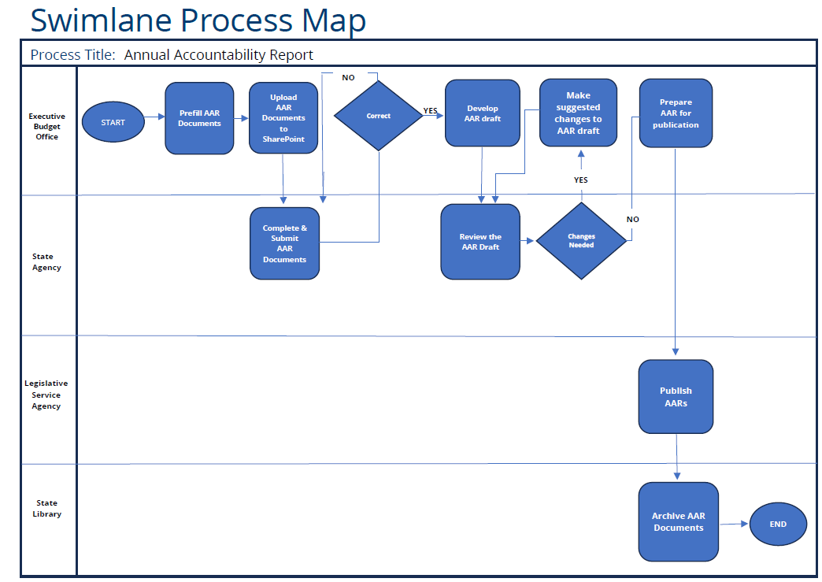

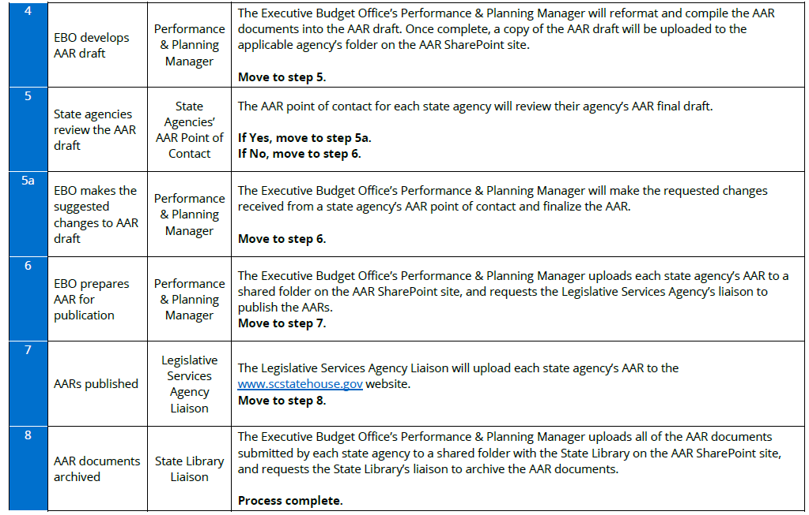

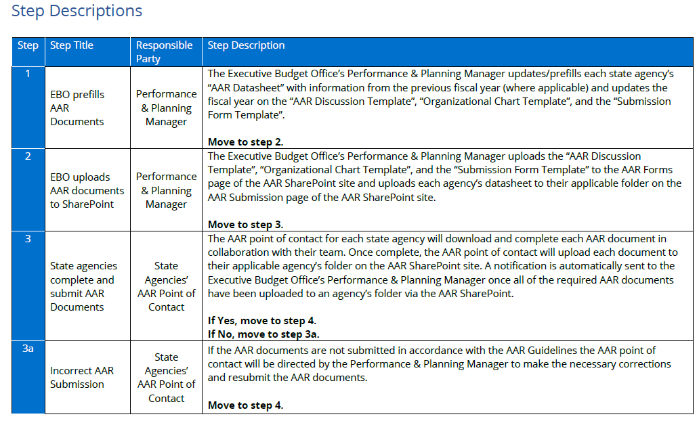

End of RFI

