

June 17, 2026

Request for Proposals (RFP) 26-100
Real Property Appraisal Services – Special Franchise Properties and Telecommunications Assessment Ceiling Properties
Notice to Bidders

To All Potential Bidders:
The Department has found it necessary to slightly amend the scope for the above-mentioned RFP to remove reference to the 2026 assessment roll year. Accordingly, the Proposal Due date is being extended to July 9, 2026. An official amendment, including a new Schedule of Events, will be posted to the Department’s website as soon as possible.
Bidders who have already submitted a proposal package to the Department will be contacted directly regarding return of their submitted bid. We appreciate your interest and apologize for any inconvenience caused by this delay.

Sincerely, 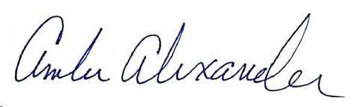
Amber Alexander
Director, Procurement Service

